Names: Tuyishime Ange

ID:24314

PROJECT NAME: Choir Registration and concert publishing

Purpose of the Project:

The purpose of my project is to develop a web-based platform to registering the choir and promoting their upcoming concert The platform will enable choirs to create their profiles, publish concert listings, and engage with potential attendees. The project will involve user registration and authentication, choirs registration with verification, concert creation and promotion. The platform will prioritize accessibility and responsiveness across devices and browsers.

**Expected Outcomes:**

**Choirs Registration:** The platform will provide a user-friendly interface for black entrepreneurs to easily register their businesses.

**Concert Promotion**: Entrepreneurs can publish their upcoming events on the platform, allowing them to showcase their offerings and reach a wider audience.

**Automatic Event Dismissal:** Once an event's scheduled date has passed, the system will automatically remove it from the platform, ensuring that only relevant and active events are displayed.

**User Registration and Authentication:**

**User Registration:** Users can create accounts on the platform. The registration process will collect necessary information such as name, email, and other relevant details.

**Authentication:** The web app will implement a secure authentication system to verify user credentials during the login process. This can involve password-based authentication or other authentication methods like two-factor authentication for enhanced security.

**Account Management**: Users will have the ability to manage their accounts, including updating personal information, resetting passwords, and managing notification preferences.

**choirs Registration:**

Business Profile Creation: The platform will provide a feature that enables black entrepreneurs to create detailed profiles for their businesses. This may include information such as business name, description, location, contact details, and social media links.

**Verification Process:** A verification mechanism will be implemented to ensure the authenticity of registered businesses. This may involve manual verification by platform administrators or an automated verification process.

**Concert Publication:**

**Event Creation**: Entrepreneurs can create event listings by providing event details such as title, description, date, time, location, and any other relevant information.

**Event Categorization:** The platform will provide options for entrepreneurs to categorize their events based on industry, theme, or other relevant criteria to facilitate easy searching and browsing.

**Event Promotion:** Entrepreneurs will be able to promote their events by including images, videos, or other media to attract potential attendees.

**Event Duration and Expiration:** A mechanism will be implemented to set the duration of events and automatically remove them from the platform once their scheduled dates have passed.

**Constraints or Limitations:**

According to my view, there are no specific limitations or constraints for the project. However, it's important to consider certain aspects:

**Technical Limitations:** The platform should be able to handle a significant number of registrations and event postings without performance issues.

**User Experience**: An intuitive and user-friendly interface will be created that requires minimal technical knowledge to register businesses and publish events.

**Security:** Robust security measures will be implemented to protect user data and prevent unauthorized access to the platform.

Project Plan:

**Scope:**

Develop a user-friendly web-based platform for black entrepreneurs in Africa.

Implement features for user registration, business registration, event publication, and user interaction.

Design and build a scalable and secure system architecture.

Ensure platform accessibility and responsiveness across devices and browsers.

Incorporate automatic event removal functionality for expired events.

Timeline:

The project timeline will be divided into the following phases:

a. Requirements Gathering and Analysis: 2 days

b. System Design and Architecture: 4 days

c. Front-end and Back-end Development: 1 week

d. Testing and Quality Assurance: 2 days

e. Deployment and Launch: 1 day

f. Ongoing Maintenance and Support: Continuously

**Resources:**

**Spring Boot Documentation:** The official documentation provided by Spring Boot is an excellent resource to get started. It covers a wide range of topics, including setup, configuration, building RESTful APIs, working with databases, security, and more. You can find the documentation at: [insert URL]

**Spring Initializr:** Spring Initializr is a web-based tool that helps you generate a Spring Boot project with the necessary dependencies and configuration. You can customize your project by selecting specific dependencies, such as Spring Web, Spring Data JPA, and more. Visit the Spring Initializr website at: [insert URL]

**Spring Guides:** Spring Guides is an official collection of tutorials provided by the Spring team. It covers a wide range of topics, including building web applications, data access, security, and deployment. These guides provide step-by-step instructions and sample code to help you learn and implement Spring Boot effectively. Explore the Spring Guides at: [insert URL]

**Database Schema**:

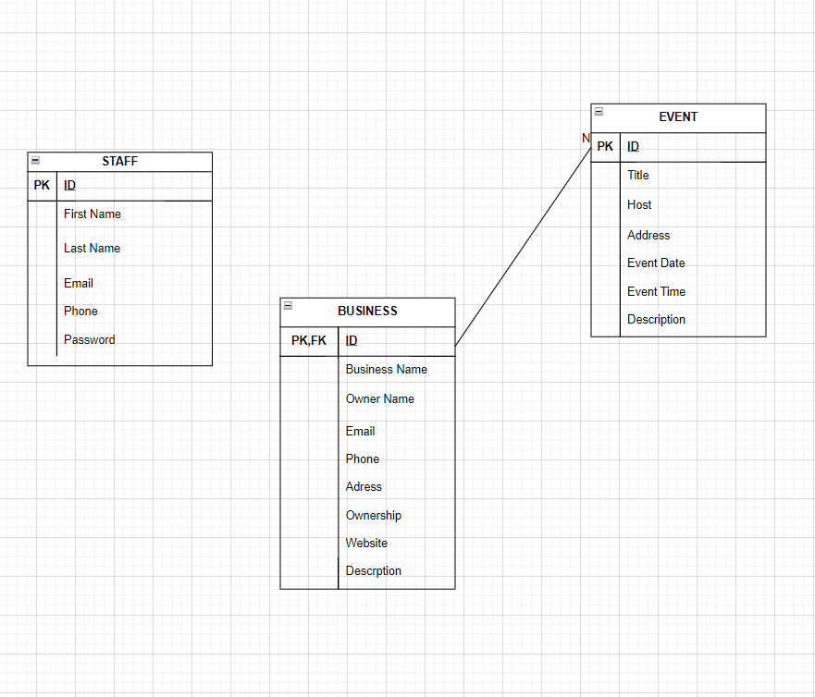

**User Documentation:**

Welcome to the African Entrepreneurs Platform! This user guide will provide you with an overview of the application, including login credentials, navigation instructions, and available features and functionality.

**Login Credentials:**

To access the platform, visit [http://localhost:4200/].

Use the following credentials to log in:

Username: [muhireclaude070@gmail.com]

Password: [23214]

If you haven't registered yet, click on the "Sign Up" button and follow the registration process.

**Navigation:**

Once logged in, you will be directed to the platform's dashboard. Here's a brief overview of the main sections and their functionalities:

**Home:** The home page displays a feed of recent events and business updates. You can scroll through the feed to discover new events.

**My Profile:** This section allows you to manage your profile information, including your username, email address, and business details (if applicable). You can update your profile information and view your business details here.

**Create Business:** If you own a business, you can create and manage your business profile by clicking on this section. Fill in the necessary details, such as the business name, description, and contact information.

**Events:** This section enables you to create and manage event listings. You can create new events, specify event details (name, description, date), and promote them to attract attendees.

**Explore:** The explore section allows you to browse through various events and businesses. Use the search functionality or filter options to find events or businesses based on specific criteria.

**Logout:** To safely log out of the platform, click on the "Logout" option located in the navigation menu.

**Additional Features and Functionality:**

**Automatic Event Removal:** Expired events are automatically removed from the platform, ensuring that only current and relevant information is displayed.

**Support and Assistance:**

If you encounter any issues, have questions, or need assistance, please contact our support team at **[muhireclaude070@gmail.com/0785395123].**

We value your feedback and suggestions for improving the platform. Feel free to share your ideas and suggestions with us.

Technical Documentation:

**Architecture:** My web app project follows a client-server architecture and uses the Model-View-Controller (MVC) and RESTful APIs frameworks.

**Implementation:** To develop this application, I used Angular programming language for the front-end, Java for the back-end, MySQL for the database management system, and IntelliJ for the back-end and VS Code for the front-end as the IDEs.

**Libraries and Frameworks:**

**Spring Boot:**

**spring-boot-starter-web:** Provides the necessary dependencies for building web applications with Spring Boot.

**spring-boot-starter-test:** Includes dependencies for testing Spring Boot applications.

**Selenium:**

**selenium-java:** A Java binding for Selenium WebDriver, used for automating web browser interactions and testing.

**ngWebDriver:** ngwebdriver: A library that provides additional support for AngularJS applications in Selenium WebDriver tests.

**WebDriverManager:** webdrivermanager: A library that automates the management of WebDriver binaries (e.g., Chrome Driver, Gecko Driver) required for browser automation.

**TestNG:** testing: A testing framework for Java that offers additional features and flexibility compared to JUnit.

**Spring Framework:**

**spring-web:** Part of the Spring Framework, which provides support for web development and handling HTTP requests.

**MySQL Connector:** mysql-connector-java: The JDBC driver for connecting to a MySQL database.